ORD & Business Rules

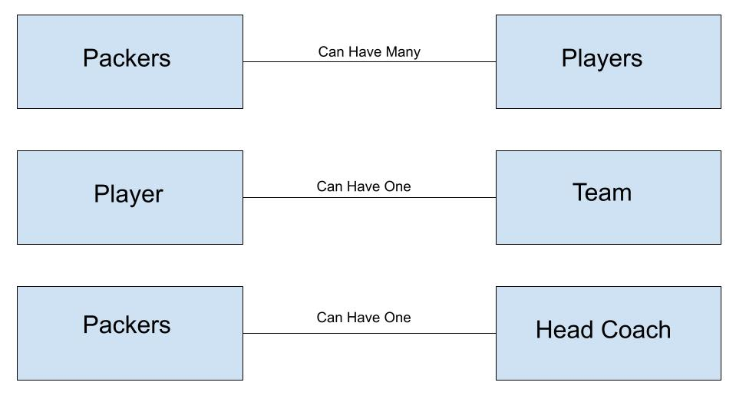**Packers Model**

|  |  |  |
| --- | --- | --- |
| **Field Name** | **Data Type** | **Schema** |
| city | String | n/a |
| name | String | n/a |
| players | Array | playerSchema |
| headCoach | String | headCoachSchema |

**Players Schema**

|  |  |  |
| --- | --- | --- |
| **Field Name** | **Data Type** | **Schema** |
| firstName | String | n/a |
| lastName | String | n/a |
| position | String | n/a |
| team | String | n/a |
| salary | Number | n/a |

**Head Coach Schema**

|  |  |  |
| --- | --- | --- |
| **Field Name** | **Data Type** | **Schema** |
| firstName | String | n/a |
| lastName | String | n/a |
| salary | Number | n/a |